**HIPAA**

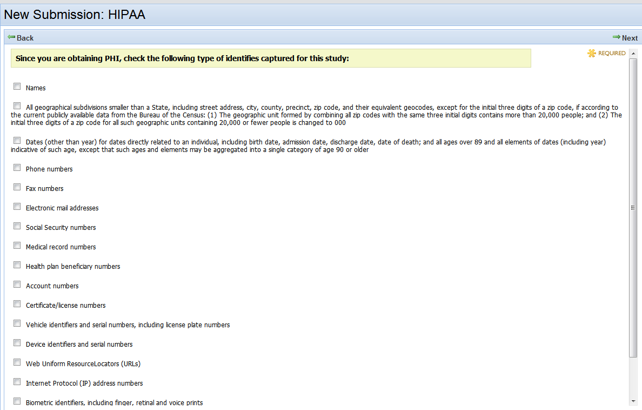

Edit:

Change “identifies” to “identifiers”

Change capital S in “State” to lower case s

Change to “Dates (other than year) directly related…” (remove “for dates”)

Add a space between “Resource” and “Locators” in Web Uniform Resource Locators

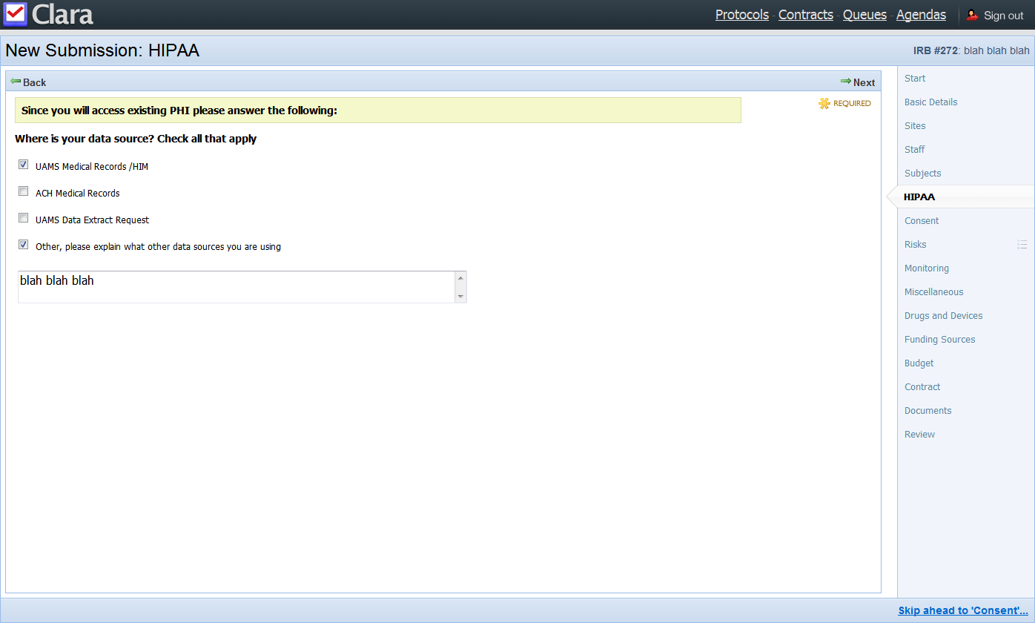

Edit:

Add period to “Check all that apply.”

Return after Other.

On separate line, put “Please explain what other data sources you are using.”

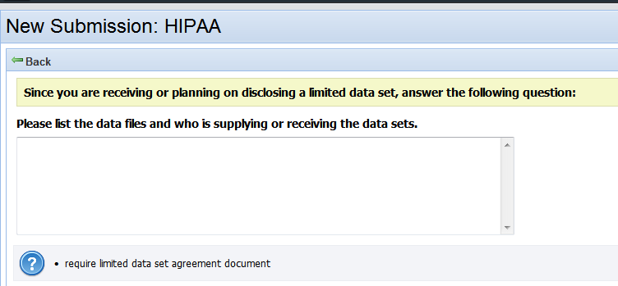

Help Text:

Limited Data Set Agreement required. Contact xxxx for more information.

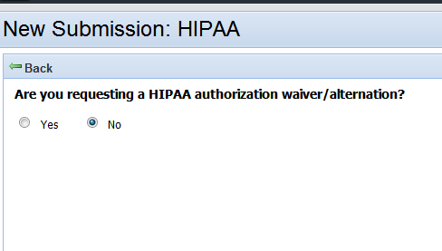

Edit:

Change “alternation” to “alteration”

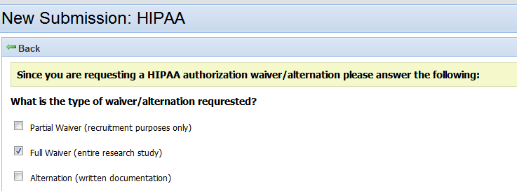

Edit:

Change “waiver/alternation” to “waiver/alteration” in the rest of the HIPAA screens.

Change to “What is the type of waiver/alteration requested?” (correct spelling of “alteration” and “requested”)

Correct spelling of “alteration” in last option

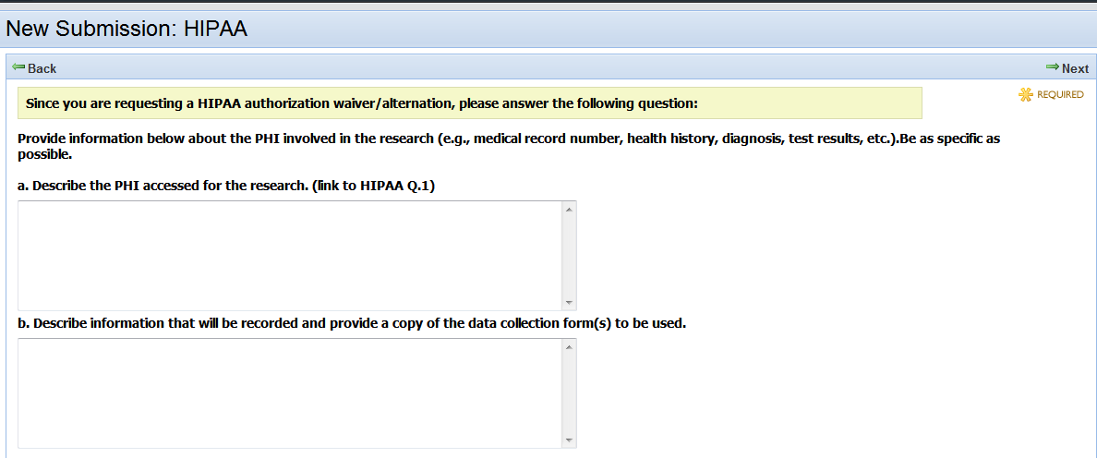

Edit:

Add a space between end parenthesis and “Be…”

What is the link to HIPAA Q.1?

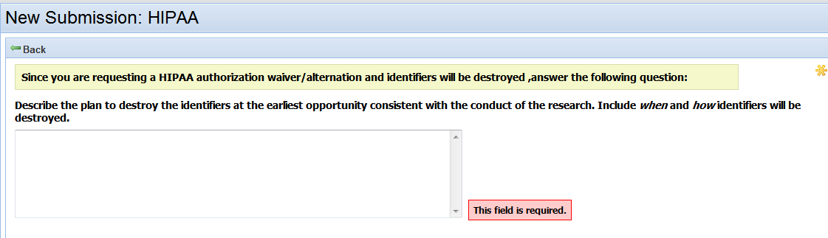

Edit:

Move space to after comma, between “destroyed” and “answer,” in this screen and the next screen.